How to add University branding to your Microsoft Form

Creating a new Microsoft Form using CMR’s University branding
CMR has created a University-branded Microsoft Form template, which should be used as the basis for your own MS Form. You need to click "Duplicate it" to copy the template to your own MS Form, and you can start building your own questions into Section 1.

Updating your existing Microsoft Form with CMR’s University branding
If you have already created your form, you can manually add the theme style to your existing form by following these steps:

Step 1: Edit the theme
Edit your Form theme by choosing “Theme” from the menu bar
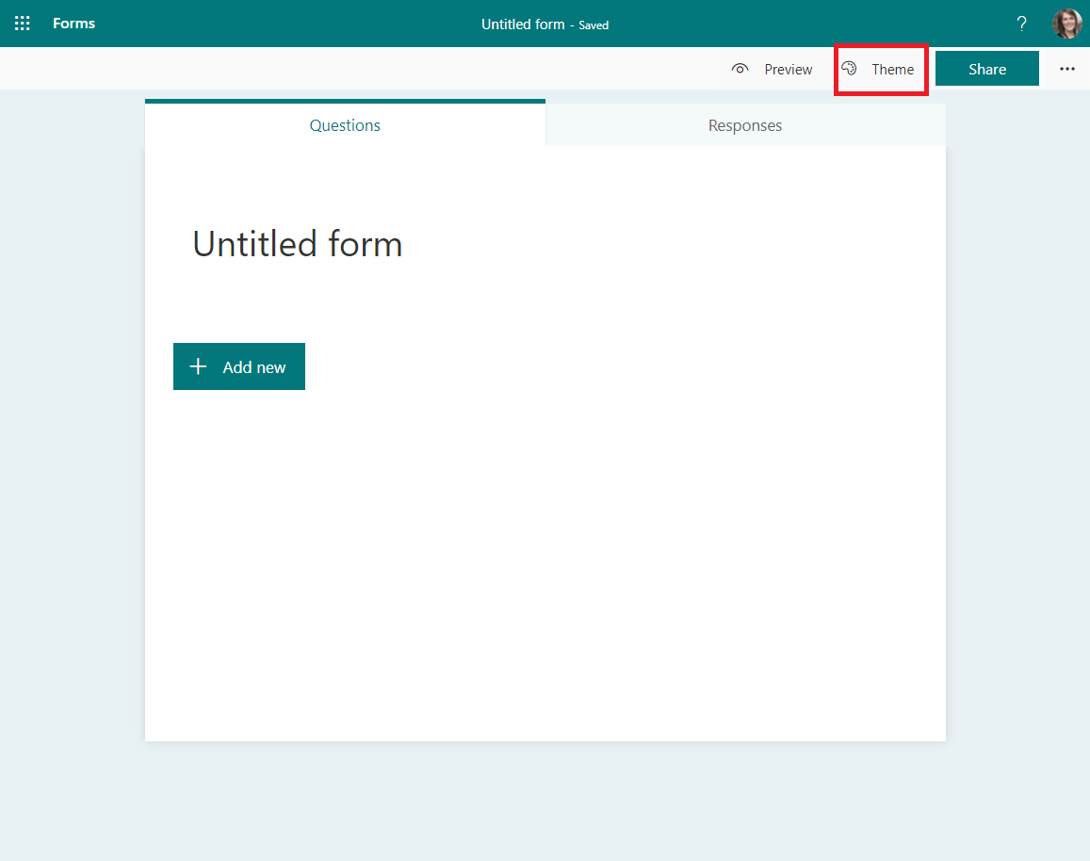

Step 2: Customise the theme
Choose the “Customise theme” option:
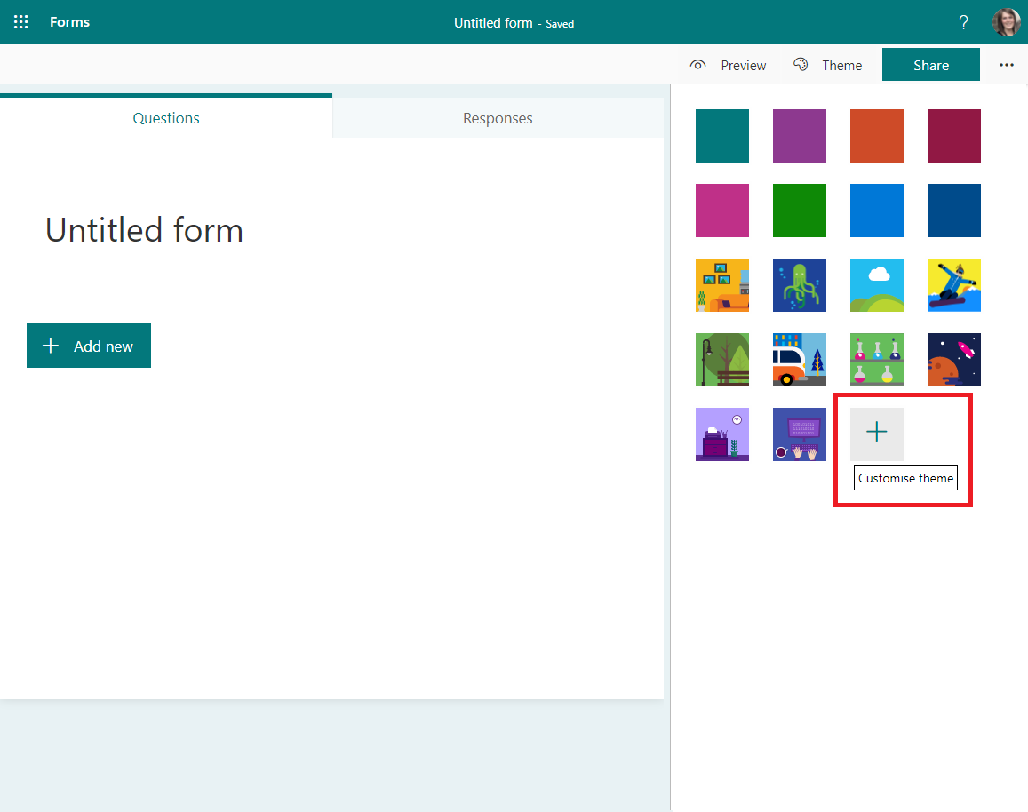

Step 3: Customise the colour
Choose the “Customise colour” option and insert the hex code for Heritage Green #006938:
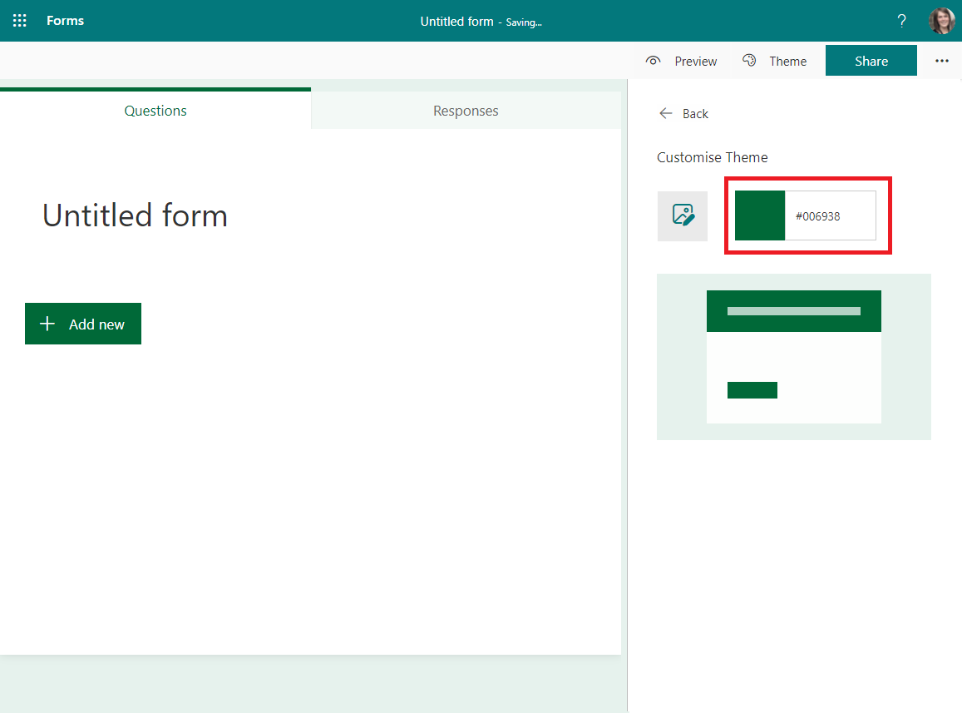

Step 4: Add the University logo
Click on your Form heading, choose the “Insert image” option and upload the University of Stirling logo “Mono reversed logo (White) one colour” (Logos can be downloaded from the Brand Bank.)
